1. What is Finite Automata and Differentiate DFA, NFA.

2. Consider the following NFA and convert into DFA.

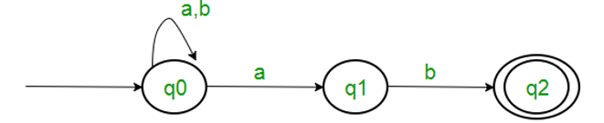

3. a) Design FA with ∑ = {0, 1} accepts the string which contains two consecutive 0’s and three consecutive 1’s.

b) Design an NFA with ∑ = {0, 1} accepts all string starting with 10 and ending with 01.

4. Convert the following CFG into CNF.

S → ASA | aB, A → B | S, B → b | ε

5. a) Design a FA from given regular expression 10 + (0 + 11)0\* 1.

b) Write the regular expression for the language accepting all the string which are starting with 1 and ending with 0, over ∑ = {0, 1}.

6. Convert the given NFA with epsilon to NFA without epsilon.

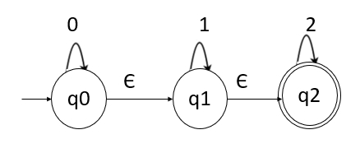

7. What is Input Buffering? Explain with example.

8. Explain in detail about Phases of Compiler.

9. What is Lexical Analysis? Explain with example.

10. Differentiate between Compiler and Interpreter.